**AI-Powered Learning**

Revolutionizing Certification Preparation

[[Roger Nem](https://medium.com/@rogernem?source=post_page---byline--b79714e2bd9a---------------------------------------)](https://medium.com/@rogernem?source=post_page---byline--b79714e2bd9a---------------------------------------)

[Roger Nem](https://medium.com/@rogernem?source=post_page---byline--b79714e2bd9a---------------------------------------)

12 min read



AI-powered Study Companion (picture by author)

Embarking on the journey to achieve an [AWS Certification](https://aws.amazon.com/certification/) can feel like preparing for a marathon — both exciting and daunting at the same time. The sheer volume of documentation, training resources, practice exams, and hands-on labs available can be overwhelming for many aspiring cloud professionals. Between juggling work commitments, personal life, and the vast array of study materials, maintaining consistency and structure in your preparation can become a significant challenge.

The complexity doesn’t end with the amount of content. AWS services are constantly evolving, with new features and updates being released regularly. This dynamic nature of the cloud environment makes it crucial to stay current while preparing for certification exams. Many learners find themselves struggling to identify which resources to focus on, how to structure their study time effectively, and how to ensure they’re covering all the necessary topics in sufficient depth.

Having recently [passed the AWS Certified Security Specialty exam](https://medium.com/@rogernem/how-i-cleared-the-aws-security-specialty-exam-in-12-days-in-2025-dd63c5f1f9bd), I understand firsthand the challenges of certification preparation.

**[How I cleared the AWS Security Specialty exam in 12 days in 2025](https://medium.com/@rogernem/how-i-cleared-the-aws-security-specialty-exam-in-12-days-in-2025-dd63c5f1f9bd?source=post_page-----b79714e2bd9a---------------------------------------" \t "_blank)**

[Tips and Tricks to pass the AWS Certified Security — Specialty SCS-C02 Exam](https://medium.com/@rogernem/how-i-cleared-the-aws-security-specialty-exam-in-12-days-in-2025-dd63c5f1f9bd?source=post_page-----b79714e2bd9a---------------------------------------" \t "_blank)

[rogernem.com](https://medium.com/@rogernem/how-i-cleared-the-aws-security-specialty-exam-in-12-days-in-2025-dd63c5f1f9bd?source=post_page-----b79714e2bd9a---------------------------------------" \t "_blank)

While I succeeded by developing structured study strategies and leveraging various AWS learning resources, I realized there could be an even more efficient way to approach certification preparation. My experience showed me that having a system to break down complex concepts, generate relevant practice scenarios, and maintain consistent study momentum was crucial.

But what if there was a way to make this journey more manageable? What if you had access to a personal certification coach available 24/7, ready to break down complex concepts, quiz you on demand, and help you maintain focus on your certification goals? This is where the power of artificial intelligence, specifically through [Amazon Bedrock](https://aws.amazon.com/bedrock/) and Anthropic’s Claude models, comes into play.

This article explores how you can leverage [generative AI](https://aws.amazon.com/generative-ai/), specifically through Claude models available in Amazon Bedrock, to create your own personalized AWS certification preparation assistant. By harnessing this AWS-managed service, you’ll learn how to build an AI-powered study companion that helps you master key concepts, simplifies complex AWS topics, and maintains your focus throughout your certification journey.

**Table of Contents**

1. [The Value of AWS Certifications](https://medium.com/@rogernem/ai-powered-learning-b79714e2bd9a#4e85)
2. [Definitions](https://medium.com/@rogernem/ai-powered-learning-b79714e2bd9a#fa0c)  
   [AI Foundation Models (FMs)](https://medium.com/@rogernem/ai-powered-learning-b79714e2bd9a#2c42)  
   [Large Language Models (LLMs)](https://medium.com/@rogernem/ai-powered-learning-b79714e2bd9a#865e)  
   [Transforming Technical Learning with LLMs](https://medium.com/@rogernem/ai-powered-learning-b79714e2bd9a#16e3)  
   [The Foundation of Generative AI](https://medium.com/@rogernem/ai-powered-learning-b79714e2bd9a#6a30)  
   [Amazon Bedrock — A Comprehensive AI Platform](https://medium.com/@rogernem/ai-powered-learning-b79714e2bd9a#fec9)
3. [Prerequisites](https://medium.com/@rogernem/ai-powered-learning-b79714e2bd9a#cd5d)
4. [AI Study environment setup](https://medium.com/@rogernem/ai-powered-learning-b79714e2bd9a#2662)
5. [Creating effective study prompts](https://medium.com/@rogernem/ai-powered-learning-b79714e2bd9a#e427)
6. [Best Practices for Success](https://medium.com/@rogernem/ai-powered-learning-b79714e2bd9a#aa6b)
7. [Conclusion](https://medium.com/@rogernem/ai-powered-learning-b79714e2bd9a#aa6b)

**The Value of AWS Certifications**

In today’s technology-driven world, AWS Certifications stand as benchmarks of cloud computing expertise. The statistics speak volumes about their impact: as we move through 2025, **more than 1.42 million active certifications** are held by over a million professionals globally.

These credentials aren’t just badges — they’re transforming how organizations operate. Studies reveal that organizations with AWS-certified staff experience remarkable improvements: **91%** see enhanced innovation in AWS implementations, while**90%** report higher productivity levels.

With industry projections showing a**28%**surge in cloud-related positions over the next five years, these certifications have become essential.

**Definitions**

**AI Foundation Models (FMs)**

[Foundation Models](https://aws.amazon.com/what-is/foundation-models/) (FMs) represent the backbone of modern artificial intelligence systems. These are large-scale AI models trained on vast amounts of data that can be adapted for a wide range of tasks. Foundation Models serve as the base architecture upon which more specialized AI applications are built, including language processing, image generation, and complex problem-solving capabilities.

In the context of AWS certification preparation, Foundation Models available through Amazon Bedrock provide the underlying intelligence that powers various learning tools and features. These models, from providers like Anthropic, AI21 Labs, Cohere, and others, form the basis for creating sophisticated, interactive learning experiences.

**Large Language Models (LLMs)**

[Large Language Models](https://aws.amazon.com/what-is/large-language-model/) (LLMs) represent a groundbreaking advancement in artificial intelligence that has fundamentally changed how machines understand and interact with human language. These sophisticated AI systems are trained on massive datasets of text, enabling them to process, understand, and generate human-like text with remarkable accuracy and contextual awareness.

At their foundation, LLMs work by analyzing patterns in language, understanding relationships between words and concepts, and learning the nuances of communication. Think of them as highly advanced language processors that can comprehend context, recognize subtle meanings, and engage in meaningful dialogue. Unlike traditional rule-based systems, LLMs can adapt their responses based on context and continue learning from interactions.

Key characteristics of LLMs include several important aspects. In terms of **Natural Language Understanding**, these models excel at comprehending complex queries, recognizing context and nuance, and processing multiple languages and communication styles. Their **Contextual Awareness** allows them to maintain conversation coherence, understand references to previous information, and adapt responses based on ongoing dialogue. When it comes to **Knowledge Integration**, LLMs demonstrate impressive capabilities in accessing broad knowledge bases, connecting related concepts, and understanding technical terminology.

**Transforming Technical Learning with LLMs**

When applied to AWS certification preparation, LLMs become powerful learning companions that transform the learning experience in several ways. They provide dynamic support by offering instant, contextual explanations of complex AWS concepts, while generating relevant practice questions tailored to specific certification requirements. Their ability to adapt explanations to match individual learning styles ensures that each student can grasp concepts in the most effective way for them.

The interactive learning capability of LLMs enables engaging question-and-answer sessions, where students can receive alternative explanations when concepts aren’t clear and get immediate feedback on their practice responses. This immediate interaction helps reinforce learning and correct misunderstandings in real-time.

One of the most valuable aspects of LLMs is their ability to facilitate comprehensive understanding. They excel at breaking down complex topics into manageable pieces, creating meaningful connections between related AWS services, and explaining concepts using varied examples and analogies that resonate with learners.

Perhaps most importantly, LLMs maintain consistent availability, serving as 24/7 study support systems that provide reliable, high-quality responses and unlimited practice opportunities. This constant availability ensures that learning momentum can be maintained regardless of time constraints or scheduling challenges.

**The Foundation of Generative AI**

[Generative AI](https://aws.amazon.com/generative-ai/) represents a revolutionary advancement in artificial intelligence technology that goes beyond traditional data analysis and pattern recognition.

At its core, it encompasses systems that can create new, original content based on the patterns and information they’ve learned from training data. Unlike conventional AI systems that simply process and analyze existing information, generative AI can produce new text, images, code, and other forms of content that never existed before.

In the context of AWS certification preparation, generative AI serves as a dynamic educational tool that transforms the learning experience. It creates personalized learning experiences by tailoring study materials to individual learning styles and adapting explanation complexity based on understanding levels. The technology excels at developing realistic case studies and varied problem-solving scenarios that mirror actual AWS implementations, helping students build practical knowledge through hands-on examples.

The real strength of generative AI lies in its ability to provide interactive learning support with immediate, detailed feedback and alternative explanations when needed. It can identify knowledge gaps through interactive sessions and adjust difficulty levels based on performance, ensuring that learning remains challenging yet achievable.

**Amazon Bedrock — A Comprehensive AI Platform**

[Amazon Bedrock](https://aws.amazon.com/bedrock/) represents a sophisticated bridge between users and powerful AI models. As a fully managed service, it eliminates the complexity of deploying and managing AI infrastructure, allowing users to focus entirely on their learning objectives. The platform provides seamless access to various AI models from industry leaders including Anthropic, AI21 Labs, Cohere, Amazon, Meta, Mistral AI, OpenAI and Stability AI.

What sets Amazon Bedrock apart is its flexible, pay-as-you-go pricing model, making it cost-effective for certification preparation. Users only pay for the resources they actually use, allowing for efficient budget management while maintaining access to powerful AI capabilities. The platform’s interactive Chat/Text playground enables immediate engagement with AI models, creating an environment where learners can experiment with different learning approaches and receive instant feedback.

**Prerequisites**

Before you begin, you need to have and **AWS account.** You can sign up [here](https://aws.amazon.com/) and follow this [tutorial](https://aws.amazon.com/premiumsupport/knowledge-center/create-and-activate-aws-account/) to set it up. After that you’ll need appropriate permissions in [AWS Identity and Access Management (IAM)](https://aws.amazon.com/iam/). For detailed permission configuration guidance, refer to the [Identity-based policy examples for Amazon Bedrock](https://docs.aws.amazon.com/bedrock/latest/userguide/security_iam_id-based-policy-examples.html) documentation.

Navigate to the Amazon Bedrock Console and enable model access. Amazon Bedrock is a **pay-as-you-go pricing model**, which means you’ll only be **charged for what you use during your AWS study sessions**. You can keep track of your usage through the [AWS Management Console](https://aws.amazon.com/console/), helping you manage costs effectively. Refer to [Amazon Bedrock pricing](https://aws.amazon.com/bedrock/pricing/) to learn more about specific costs for each foundational model.

**AI Study environment setup**

Once you have access to the Amazon Bedrock console, the first step is to navigate to “**Model access**” under “**Configure and Learn**” section.

Press enter or click to view image in full size

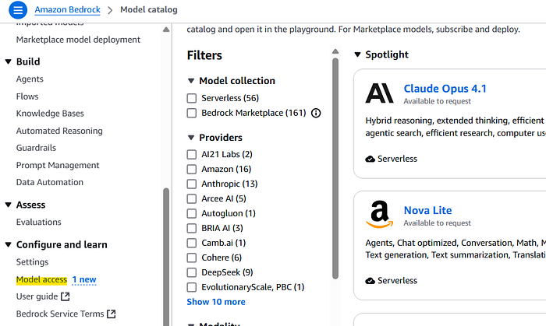

AWS Model Access (picture by author)

Enable access specifically for your chosen model from the available foundation models. For this guide, we’ll use **Claude Sonnet 4**, though Amazon Bedrock offers access to various other powerful models from providers like AI21 Labs, Cohere, Meta, and Mistral AI. Each model has its own strengths and capabilities, so you can choose the one that best suits your learning style and needs.

Claude Sonnet 4 can effectively process complex instructions while being aware of context and can fix its own errors. It can analyze complicated information to provide meaningful insights. The system is versatile — capable of giving quick answers or breaking down its thought process into detailed steps that users can follow.

Click on “Available to request” and then on “**Request model access”**.

Press enter or click to view image in full size

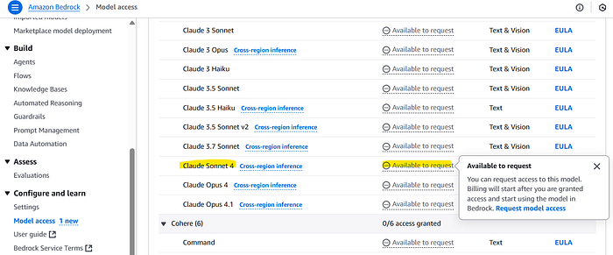

AWS Model Access Request (picture by author)

On the next screen, make sure the correct model is select and click on “**Next**” at the bottom of the screen.

Press enter or click to view image in full size

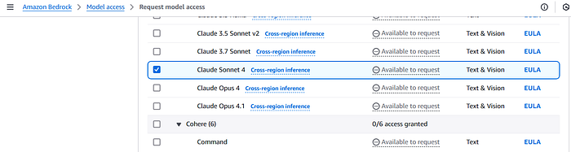

Request Model Access (picture by author)

Review the terms and click on “**Submit**”.

Press enter or click to view image in full size

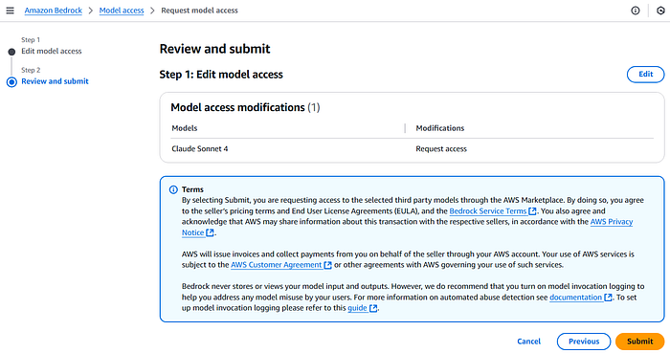

AWS Model Access Review and Submit Screen (picture by author)

You should see the model access request submitted.

Press enter or click to view image in full size

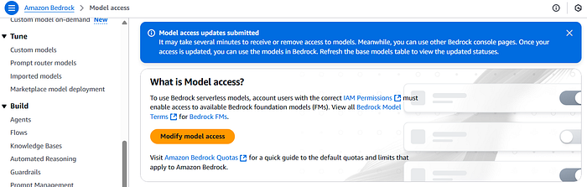

Successful AWS Model Access Request (picture by author)

Scroll down to confirm the access has been granted, as shown below.

Press enter or click to view image in full size

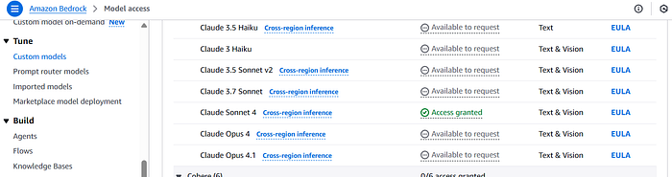

AWS Model Access Granted (picture by author)

Next, you’ll need to access the Amazon Bedrock **Chat/Text playground**.

Press enter or click to view image in full size

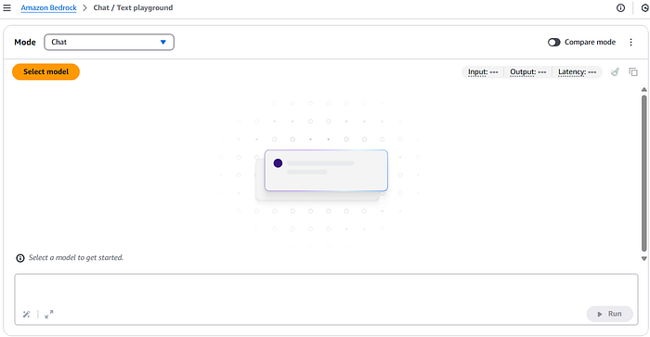

Amazon Bedrock Chat/Text Playground screen (picture by author)

Click on “**Select model**”. On the pop-up screen, click on “**Anthropic**” and then select **Claude Sonnet 4** from the available FMs, as shown in the following screenshot. Once done click “**Apply**”.

Press enter or click to view image in full size

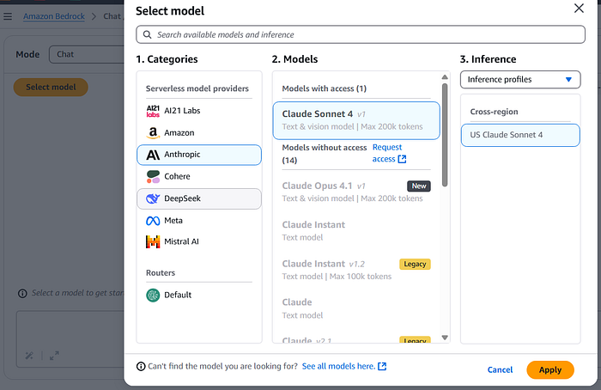

Amazon Bedrock Chat/Text Playground Model Selection (picture by author)

Next we’ll add a **system prompt**. A system prompt establishes the initial context and behavior parameters for the AI model. It defines your study coach’s role and baseline instructions.

Here’s an example system prompt for the Amazon Bedrock chat console:

*You are an AWS Certification Coach*expert *with deep knowledge of AWS services and certification exams. You specialize in the****AWS Solutions Architect Associate certification****. Use the documentation uploaded to understand the exam you are generating questions for. Always base your answers on official AWS documentation and best practices. Keep explanations clear and focused on exam-relevant details. If unsure about any information, acknowledge the uncertainty and refer to official AWS documentation.*

Press enter or click to view image in full size

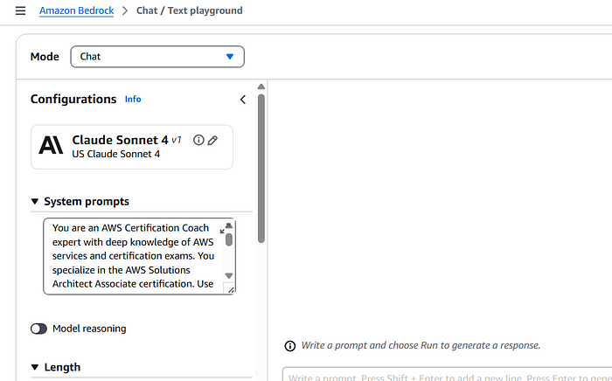

Amazon Bedrock Chat/Text Playground System Prompt Screen (picture by author)

The next crucial step is uploading your study materials to the AI environment. In the chat interface, you’ll find a document upload feature that allows you to provide essential context to your AI study companion. This step is fundamental for creating an effective certification coach, as it ensures the AI has access to accurate, certification-specific information. While the system prompt we created earlier sets the behavioral framework for the AI, it’s the official AWS documentation that provides the detailed knowledge base needed for precise, exam-relevant responses.

For example, if you’re preparing for the Solutions Architect Associate certification, you should upload the [official exam guide](https://d1.awsstatic.com/training-and-certification/docs-sa-assoc/AWS-Certified-Solutions-Architect-Associate_Exam-Guide.pdf) and related AWS documentation. This ensures your AI coach can draw from authoritative sources when providing explanations, generating practice questions, or discussing specific AWS services. The more relevant documentation you provide, the better equipped your AI companion will be to support your certification journey with accurate, focused guidance.

You can access certification-specific content from [AWS Skills Builder](https://skillbuilder.aws/). For this use case, we upload the [AWS Solutions Architect Associate Exam Guide](https://d1.awsstatic.com/training-and-certification/docs-sa-assoc/AWS-Certified-Solutions-Architect-Associate_Exam-Guide.pdf) to properly orient the model to the certification requirements.

Press enter or click to view image in full size

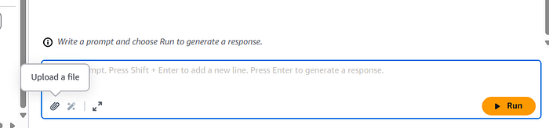

Upload a file Screen (picture by author)

Next we add instructions to our prompt:

*Please use this AWS Solutions Architect Associate exam guide as reference for our discussion. This document contains the official exam content and objectives.*

Press enter or click to view image in full size

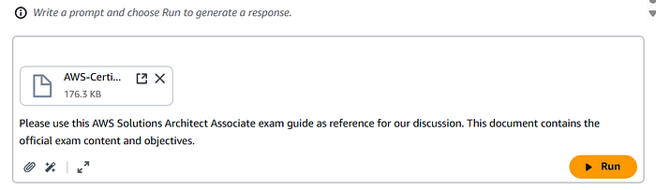

File Uploaded Screen (picture by author)

**Creating Effective Study Prompts**

The success of your AI-assisted study sessions largely depends on how well you communicate with your AI coach. This is where [prompt engineering](https://aws.amazon.com/what-is/prompt-engineering/) comes into play — the art of crafting clear, specific instructions that elicit the most helpful responses from your AI study companion.

Instead of asking broad, general questions, focus on creating targeted, context-rich prompts. For example, rather than simply asking “*Tell me about Amazon S3*,” you’ll get better results by requesting “*Explain the key differences between Amazon S3 and Amazon EBS, specifically focusing on aspects relevant to the Solutions Architect Associate exam*.” Always remember to specify which certification you’re preparing for to ensure relevant, appropriately-scoped responses.

Here are practical prompts to try with your AI study companion:

**Practice Question Generation**  
While AWS provides excellent official practice resources through [AWS Skill Builder Trivia](http://aws.amazon.com/training/digital/trivia/) and sample questions, you can use your AI coach to create additional, customized practice scenarios. Try prompts like:

*“Create a scenario-based multiple choice question about S3 lifecycle policies, including a detailed explanation of why each answer choice is correct or incorrect.”*

*“Generate five practice questions about Amazon RDS that might appear on the Solutions Architect Associate exam, with thorough explanations for each answer.”*

**Real-World Scenario Exploration**  
After completing hands-on practice in [AWS SimuLearn](https://aws.amazon.com/training/digital/aws-simulearn/) or other lab environments, use your AI coach to explore different scenarios and deepen your understanding. For instance, after working with Auto Scaling, you might prompt:

*“Walk me through how Auto Scaling, Elastic Load Balancing, and CloudWatch work together in a real-world e-commerce application. Include key architectural considerations a Solutions Architect should keep in mind.”*

**Concept Reinforcement**  
Through analogies sometimes, complex AWS concepts become clearer when explained through familiar analogies. Try prompts like:

*“Explain the AWS shared responsibility model using an analogy that a college student would understand, then highlight the key aspects that commonly appear on the Solutions Architect Associate exam.”*

The following screenshot shows the Chat/Text playground with a question and answer.

Press enter or click to view image in full size

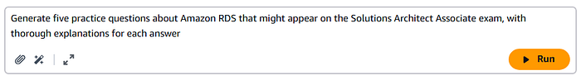

Amazon Bedrock Chat/Text Playground in Action (picture by author)

Press enter or click to view image in full size

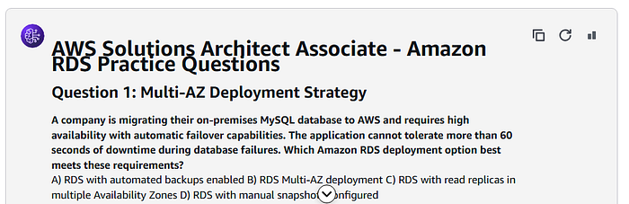

Amazon Bedrock Chat/Text Playground Question (picture by author)

Press enter or click to view image in full size

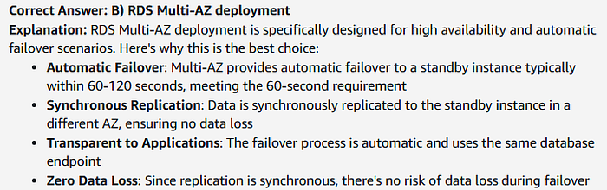

Amazon Bedrock Chat/Text Playground Answer and Explanation (picture by author)

Press enter or click to view image in full size

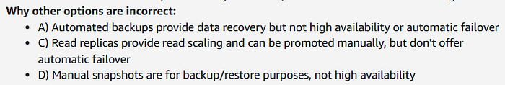

Amazon Bedrock Chat/Text Playground — Incorrect Options Explanation (picture by author)

**Best Practices for Success:**

1. Use structured study blocks to maintain focus and prevent burnout
2. Combine AI assistance with practical experience through AWS Builder Labs
3. Utilize AWS Cloud Quest for interactive learning
4. Participate in the AWS Certified Community for peer support
5. Regularly validate knowledge against official AWS documentation

**Conclusion:**

The integration of AI-powered tools represents a significant advancement in AWS certification preparation. While these tools provide powerful support for learning and understanding complex AWS concepts, they work best as part of a comprehensive study strategy that includes hands-on experience and official AWS training materials.

The journey to AWS certification remains challenging, but with the combination of Foundation Models, LLMs, and generative AI, learners now have access to sophisticated tools that can adapt to their needs, provide immediate support, and help maintain consistent progress. By leveraging these technologies while maintaining a balanced approach to learning, candidates can create a more effective, efficient, and engaging certification preparation experience.

As cloud technologies continue to evolve, the role of AI in technical education will only grow more significant. Those who can effectively combine these advanced tools with traditional learning methods will be well-positioned for success in their AWS certification journey and beyond.

Let’s learn and grow together in this exciting intersection of AI and education. 🚀

**If you enjoyed this article and found it helpful, please don’t forget to leave a heart**❤**, comment**💬**, clap**👏🏻**, and share**➦ **it to show your support.**

**Also, don’t forget to**[**connect**](https://www.linkedin.com/in/rogertn/)**,**[**follow me**](https://medium.com/@rogernem)**for more articles and support me by**[buying me a coffee](https://buymeacoffee.com/rogernem)**.**:-)**Thank you!**

References:  
- <https://aws.amazon.com/certification/>  
- <https://docs.aws.amazon.com/>  
- <https://aws.amazon.com/generative-ai/>  
- <https://aws.amazon.com/bedrock/>  
- <https://aws.amazon.com/what-is/foundation-models/>  
- <https://aws.amazon.com/what-is/large-language-model/>  
- <https://aws.amazon.com/what-is/prompt-engineering/>  
- <https://www.anthropic.com/claude>  
- <https://skillbuilder.aws/>  
- <http://aws.amazon.com/training/digital/trivia/>  
- <https://aws.amazon.com/training/digital/aws-simulearn/>

[Artificial Intelligence](https://medium.com/tag/artificial-intelligence?source=post_page-----b79714e2bd9a---------------------------------------)

[Aws Certification](https://medium.com/tag/aws-certification?source=post_page-----b79714e2bd9a---------------------------------------)

[AI](https://medium.com/tag/ai?source=post_page-----b79714e2bd9a---------------------------------------)

[Learning](https://medium.com/tag/learning?source=post_page-----b79714e2bd9a---------------------------------------)

[AWS](https://medium.com/tag/aws?source=post_page-----b79714e2bd9a---------------------------------------)